**Simulating Olson's Bandits: An ABM Exploration of Government Decision Dynamics**

Chasen Jeffries 1

1School of Social Science, Policy & Evaluation, Claremont Graduate University, Claremont California, United States of America

chasen.jeffries@cgu.edu

**Abstract.**

**Keywords:** Agent-Based Modeling (ABM), Olson’s Bandits, Complex Adaptive System, Co-Evolution, Governance

1. Introduction

In 1993 Olson published a paper that explored how bandits could be used to explain different outcomes in governance and economic performance. Olson argued that Roving and Stationary bandits are rational agents trying to maximize their gains. He identified that their decision making and characteristics can explain at once how governments are formed and the decisions they make. These heterogenous bandits, autocrats, dynamically adapt within Complex Adaptive Systems and co-evolve with their subject to maximize their fitness function. In the decades that have followed this theory has been widely reviewed and sparked debates on the origin and foundational factors affecting governance.

Olson and others (McGuire et al. 1996, Young 2016, Piano 2019) have continued to build on the initial theory. These additions seek to convey more accurately the ruler-ruled dynamic and the progression of banditry to see the arrival of governance and public goods. Banks, Olson, and Porter created an experimental model in 1997 to explore the decision making of agents based on different time horizon and risk aversion.

We build upon the established literature by simulating Olsons roaming and stationary bandits to explore if the theoretical predictions match the simulated results. Roving and stationary bandits compete in a dynamic environment to investigate how heterogenous bandit decision-making co-evolve with subjects to determine macro-outcomes. This complex system allows for feedback as the landscape and rational agents dynamically evolve to maximize their fitness functions. This model is a first step in evaluating the core principles of Olsons theory, namely the impact of government-subject relations and government decision making on economic performance.

This research has significant practical implications as the simulations highlight the impact of government-subject dynamics and government decision making on economic outcomes. Additionally, this model identifies scenarios and condition in which governments arise and evolve to identify when roving bandits choose to become stationary.

This model is an initial foray into simulating the dynamic co-evolution of rulers and ruled to better understand the decision-making of rulers and how this impacts the economic performance of government and subjects. This model focuses in on the core dynamic of Olsons model, that rational roving bandits can choose to become stationary bandits to maximize their fitness function and create a symbiotic co-evolutionary relationship between bandits and their subjects. Additionally, we simulate how the simple core decisions, like taxation and investment, by governments based on local environment dynamics lead to differential outcomes over the course of generations. This does not investigate the possible transition to democracy or problematic tendencies of autocratic successions.

1. Related Work
2. Olson’s bandits and government-subject dynamics

Olsons theory (Olson 1993) articulated that in a dynamic landscape of competing roving bandits, rational bandits would voluntarily choose to become stationary bandits because they can extract greater wealth by becoming an autocrat than through the looting associated with roving banditry. The stationary tax less than the roving bandits and provide peaceful order and some public goods. This incentivizes their subjects to invest in the future and reap greater rewards in the longer term under this new equilibria as both parties enjoy a symbiotic relationship. This provides a critical theory on how governments form, overcoming critical collective action problems.

In the years following Olsons postulation of this theory, many researchers (Young 2016, Kurrild-Klitgaard et al. 2003) have built upon Olsons foundations to explore the dynamic decision making of rulers and their competing interests to extract from society and provide public goods (McGuire et al. 1996, Kirstein et al. 2006, Piano 2019). Moselle and Polak (2001) take an alternative viewpoint arguing that while rulers may provide public goods to increase economic performance it may not increase subject welfare. The models provide clear explanations of theories but limited empirical testing of the core dynamics In 1997, Banks, Olson, and Porter developed an experimental model to investigate the decision making postulated in Olsons initial model that provided support for Olsons theory. This model does test key elements of Olsons theory, our research builds upon it and further investigates the core dynamic between rulers-subjects within a dynamically evolving landscape of roving and stationary bandits.

1. Simulations dyadic decision making in evolving landscapes

Recent decades have seen the explosion of bottom-up analyses of social sciences conducted through agent-based simulations. Epstein & Axtell release of “Growing Artificial Societies” in 1996 demonstrated the vast potential for simple models, and small iterations of these models, to provide interesting, insightful results that could alter empirical paradigms. They simulated a model where heterogenous agents, with distinct endowments of skill and resources, compete in a dynamic landscape to capture resources. This model provided groundwork for simulating social sciences processes with agent-based modeling.

This technique has used by researchers to model key scenarios and theories and contribute to empirical research by creating heterogenous agents endowed with specific capabilities and initial conditions adapting within a dynamic, uncertain landscape to maximize their fitness functions (Axtell et al. 2002, Schelling 1971, Vriend 2007). The Wolf-Sheep predation model simulates population dynamics evolution based on simple decision making and a dynamic landscape that been significantly explored (Wilensky et al. 1998, Wilensky et al. 2006, Marucco et al. 2010, Husnain 2021) to understand the dynamic co-evolution of species and demonstrate sensitive dependence on initial conditions.

These simulations provide fertile background to support our simulation efforts. The population dynamics of our bandit-subject relationship parallels the wolf-sheep predation models population dynamics. Meanwhile, we pull from the simple rules for observation and decision making from Epstein and Axtell to create our roving bandits decision tree. Finally, injecting the core decision making dynamics from Olson himself, agentized into a simple rule-set and equations allows us to model the evolving landscape articulated by Olson and the self-maximizer bandits that Olson theorized.

1. Modeling Olsons Bandits

Figure 1 shows an overview of our heterogenous bandits capabilities and decision-making method. While both bandits have the ability to tax their subjects, Roving and stationary bandits are endowed with unique capabilities to investigate a wider range of behaviors. Roving bandits, colored blue, have the capacity to run through a decision tree to determine if it should move or not. Alternatively Stationary bandits, colored red, have the capacity to invest in their subjects to provide public goods, beyond just peace.

Both bandits first observe the local environment taking in information about the resources available. Roving bandits use this information to identify the best location to build into its decision tree. This best location is the location with the most resources and no stationary bandit controlling it. After identifying the best movement option, and the cost to get there, the roving bandits run through its simple decision tree to decide whether it will move or stay on its current location. Next the roving bandits move to its destination. In the event that multiple roving bandits land on the same space, they fight and all but one of the bandits will run away to a random nearby location.

After all movement has ended, both roving and stationary bandits tax their subjects based on their desired tax rate and receive the taxed income. This tax rate is passed onto their subjects and determines their investment rate. The subjects interest rate is the inverse of their tax rate. This is based on Olsons fundamental assumption that subjects will only be incentivized to invest in their domains if they receive a portion of the gains of this investment. Subjects interests rates are calculated using the following equation:

$I_{s}=1-T_{b}-0.4$ (1)

Is is the investment rate of the subject and Tb is the tax rate of the bandit. Here we give a base rate of 0.4 that must be captured by subjects prior to investing in the future. This investment rate will slowly increase in the absence of taxation as subjects slowly increase their optimism for the future. This determines the subjects investment rate.

Next, stationary bandits invest in their subjects. This represents Olsons other key assumption, that in order for society to flourish governments must provide peaceful order and other public goods, primarily property and contract protections. This sees the bandits invest a portion of their wealth into their domain. While the published results use a simple interest equation for these investments, it has the capacity to use compound and exponential interest equations as well. This simple interest equation takes the bandits investment amount (Ib) and their investment time (Hb), the bandits time horizon, plus the interest rate, which we assume to be 0.05.

$Y=I_{b}*r*H_{b}$ (2)

After stationary bandits invest in their subjects. They cannot invest in their subjects again until the investment has matured. The subjects can invest in themselves, using their investment rate, based on equation 1, input into the simple interest formula.

Each tick within this simulation ends with the bandits taking a base attrition as they must maintain themselves or die out. Finally, the bandits that are wealthy have the capacity to reproduce, introducing new bandits of the same type (roving or stationary).

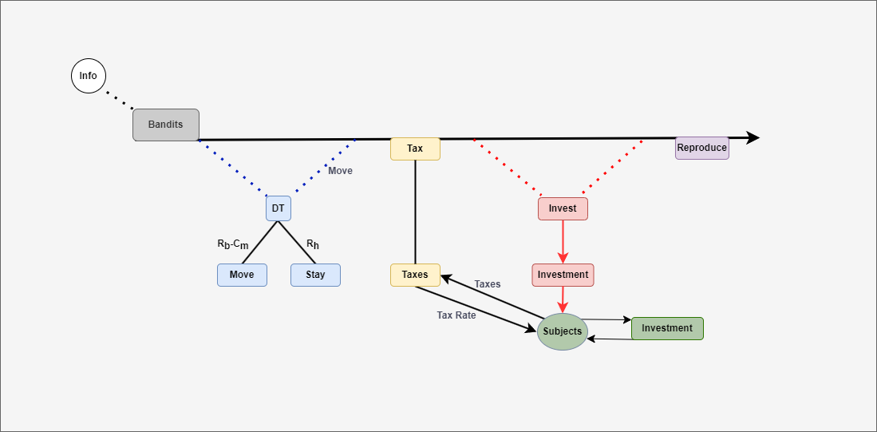**Figure 1: Bandit Decision Making Model**

1. Results
2. Baseline

To begin, we set up a benchmark to measure the standard performance of bandits in the simulation, providing a basis for comparison with other scenarios. Table 1 displays the key variable values. We take normal distributions for the bandits observation range, tax rate, investment rate, investment time and for the subjects optimism. This produces a dynamic, realistic landscape that provides bandits and subjects with a viable environment with costs.

| Parameters | Description | Base value |
| --- | --- | --- |
| Population | Total number of bandits | 50 |
| Stationary Population | The initial number of stationary bandits | 25 |
| Observation Range | How far the bandits can see around them (mean & standard deviation) | 3:1.5 |
| Move Cost | The cost for bandits to move one step. | 2 |
| Spawn Rate | The rate new bandits spawn from the fit bandits | 1 |
| Attrition Rate | The rate at wish bandit loses wealth each tick | 0.25 |
| Tax Rate | The bandits tax rate for their subjects | 0.4:0.2 |
| Investment Rate | The Stationary Bandit investment rate into their subjects | 0.25:0.125 |
| Investment Time | The Stationary Bandit time of investments | 1.5:0.75 |
| Optimism | The optimism of subjects that the future will get better. | 0.025:0.012 |

**Table 1: Baseline initial conditions and parameter values**

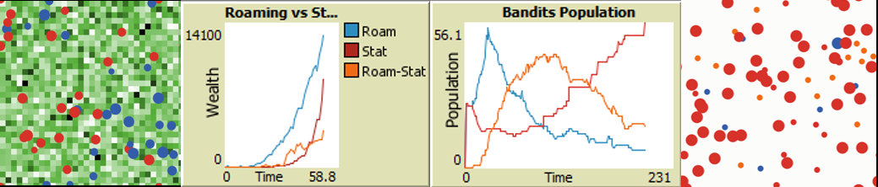**Figure 1: Baseline environment, time series wealth and population plots**

The baseline scenario demonstrates that the roving bandits outperform the stationary bandits in the short term, seen in the time series wealth plot depicting the first 25 ticks, quickly gathering resources and increasing in population. However, they cannot maintain their dominance for long and eventually the stationary bandits outperform them through their investments maturing and the increased competition between roving bandits sees the rate of returns for their fitness function fall significantly as nearly all available subjects to raid for taxes have been raided recently, having little resources and incentive to invest in themselves. The landscape evolves from one where the global environment is similar scaled and resource rich to one where the global environment is baren in comparison with the wealth concentrated in the domains of the true stationary bandits.

Interestingly, we see a dynamic where roving bandits face a bifurcation based on their tax rate. Roving bandits with lower taxes rates become stationary, turning orange after not moving for 10 consecutive ticks. They usually come to outnumber the number of roving bandits and they can maintain their fitness by acting as a simple leader of their subjects. They tax them a small amount, but they do not provide any public goods. But because they only tax a small amount their subjects are still incentivized to invest. This demonstrates that rational bandits can sustain their position as a stationary bandit, or autocrat, without choosing to provide public goods. The roving bandits that maintain their roving status are true roving bandits, they extract nearly the maximum taxes possible at rates above 90%.

Finally, the true stationary bandits, the ones capable and willing to invest in their subjects outperform both the roving bandits and those who converted to stationary. This demonstrates strong empirical support for Olsons theory as we see rational bandits choosing to become stationary and that the stationary bandits investing in their subjects outperform other bandits in the long term.

1. Scenario 1: Resource Rich

Here we want to transplant our bandits into a resource rich environment. This scenario aims to discover how the roving bandit’s decision making evolves when given an environment that is initially resource rich. Additionally, will the better starting environment provide stationary bandits with an even stronger environment to dominate the landscape and further outperform the roving bandits.

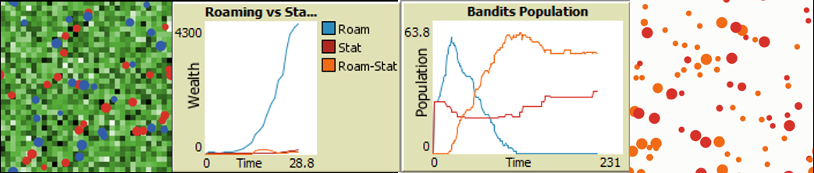  
**Figure 2: Scenario 1 environment, time series wealth and population plots**

Roving bandits die out almost every time in this new scenario. Further investigation into the population dynamics reveals that the roving bandits population explodes even more in this scenario. This creates a landscape where too many bandits compete for too many resources and they quickly deplete the landscape leading to a population collapse, similar to those seen in Wolf-Sheep predation models.

The roving bandits that rationally stop to becoming stationary perform even better in this model as they usually become the most populous agent in the model. This indicates that in the medium term the roving bandits are able to capture more resources and become fit, with their populations growing faster than stationary bandits. We cap the population at 75 agents, to limit the computational power needed to run, and the bandit populations hit the cap, but the populations of these rational roving turned stationary bandits and the stationary bandits become stable. However, while their populations remain stable, the stationary bandits again outperform the roving-stationary bandits because of their ability to provide investments in public goods that increase the economic performance of the subjects.

1. Scenario 2: Resource Rich, Low Taxes

This builds upon the resource rich landscape established in scenario one, but adds a new evolution, bandits are endowed with lower tax rates. Now ranging from 0:0.4, originally ranging 0:0.8 This seeks to better evaluate the impact of tax rate on the bandits. Will lower tax rates hurt the roving bandits more than the stationary bandits or will this low tax rate allow the roving bandits to capture gains while still keeping the subjects incentivized enough to keep the landscape fertile and prevent the population bubble and collapse identified in the previous scenario.

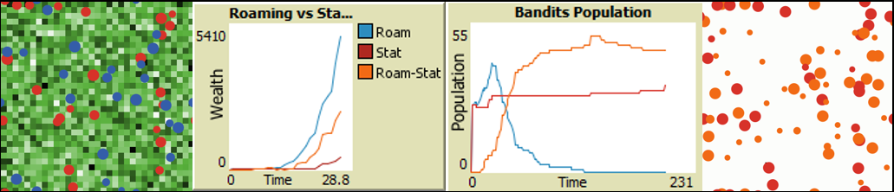  
**Figure 3: Scenario 2 environment, time series wealth and population plots**

Roving bandits die out quickly. While some of them die, most of them are simply rational agents who choose to become stationary as it is the dominant strategy. This result further emphasizes the equilibrium that is reached by roving bandits with low tax rates to survive and even thrive as roving-stationary bandits.

Stationary Bandits who can invest remain atop the model with the best ability to capture resources through its strategy of investing into their subjects. The mutual returns from investing in subjects in combination with subjects desire and ability to invest in themselves leads to a mutually advantageous outcome as both thrive. The Roving-Stationary bandits find a similar strategy, where they tax at a lower rate, but subjects are incentivized to invest in themselves and the autocrats benefit from this hands off approach.

1. Scenario 3: Resource Rich, High Taxes

Scenario 3 contrasts with Scenario 2 by investigating how high taxes, as opposed to low taxes, impacts the governance decision making and . We seeks to better understand the dynamic equilibria that roving, roving-stationary, and stationary bandits have based on their tax strategies. This scenario gives bandits high taxes rates ranging from 0.2:1, in contrast to the modest 0:0.5 of scenario 2 or 0:0.8 of the baseline.

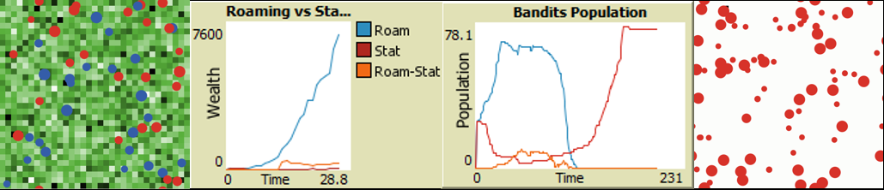  
**Figure 4: Scenario 3 environment, time series wealth and population plots**

Stationary bandits with high tax rates quickly die out, but those with low-medium tax rates survive and thrive. Similar to the stationary bandits, the only time a roving-stationary bandit survives it will have a low tax rate and they can survive the scenario.

Roving bandits appear to be the dominant strategy as very few roving bandits transition into roving-stationary bandits. The population of roving bandits grows initially before becoming seemingly stable for a period of time before the population collapses. Roving bandits do not survive in this scenario.

1. Conclusion

While this is only an initial foray into simulating Olsons bandits using a relatively simple ruleset, we do identify several conclusions. First, Rational roving bandits will adapt to the environments and set themselves up as a stationary bandit, providing peace and order. Second, these adaptive roving-stationary bandits will not provide other public goods or invest in their subjects. This represents a new previously unidentified equilibria for autocrats that contradicts Olsons assumption that for society to thrive peace and other public goods will need to be provided by the government. Third, while roving-stationary bandits can survive and thrive, stationary bandits that can provide additional public goods are the fittest agents in the model, aligning with Olsons theory.

Future models can build upon these foundations and improve the simulations alignment with Olsons theory by incorporate learning mechanics allow for bandits to adapt, optimizing their tax and investment rate to maximize their fitness. Additionally, bandits could be endowed with a more active method for determining their time horizon and predicting the future. Finally, the subjects time horizon or optimism could be a function of changes in Bandit behavior lots of change, increases uncertainty and decrease time horizon. Consistency increases it.

This can have major contributions to how we understand how governments form. This understand will be critical to learning about how the initial communities overcome the collective action problem and how nation-states undergoing civil strife may evolve to form a government. By better understanding the complex dyadic dynamic between rulers and ruled, we can better explain and predict when to major deviations in government decision making and its economic impact.

1. References:

Axtell, R. L., Epstein, J. M., Dean, J. S., Gumerman, G. J., Swedlund, A. C., Harburger, J., Chakravarty, S., Hammond, R., Parker, J., & Parker, M. (2002). Population growth and collapse in a multiagent model of the Kayenta Anasazi in Long House Valley. Proceedings of the National Academy of Sciences, 99(suppl_3), 7275-7279. https://doi.org/10.1073/pnas.092080799

Banks, J., Olson, M., & Porter, D. (1997). An Experimental Analysis of the Bandit Problem. Economic Theory, 10(1), 55–77. http://www.jstor.org/stable/25055024

Bó, E. D., Hernández, P., & Mazzuca, S. (2015). The paradox of civilization: Pre-institutional sources of security and prosperity. NBER Working Paper. http://www.nber.org/papers/w21829.

Epstein, J. M., & Axtell, R. (1996). Growing Artificial Societies: Social Science from the Bottom Up. Brookings Institution Press.

Höijer, R. (2004), Theft by Bandits and Taxation by Kings: A Critique of Mancur Olson on State-Formation. Political Studies Review, 2: 24-38. https://doi.org/10.1111/j.1478-9299.2004.00002.x

Husnain, M., & Shafi, N. (2021). An extension to wolf sheep predation (docked hybrid) agent-based model in NetLogo. Journal of Software Engineering & Intelligent Systems, 6(1).

Kirstein, R., & Voigt, S. (2006). The Violent and the Weak: When Dictators Care about Social Contracts. The American Journal of Economics and Sociology, 65(4), 863–890. http://www.jstor.org/stable/27739596

Kurrild-Klitgaard, P., Tinggaard Svendsen, G. Rational Bandits: Plunder, Public Goods, and the Vikings. Public Choice 117, 255–272 (2003). https://doi.org/10.1023/B:PUCH.0000003733.81946.d3

Marucco, F., & Mclntire, E. J. B. (2010). Predicting spatio-temporal recolonization of large carnivore populations and livestock depredation risk: wolves in the Italian Alps. Journal of Applied Ecology, 47(4), 789–798. http://www.jstor.org/stable/40835697

McGuire, M. C., & Olson, M. (1996). The Economics of Autocracy and Majority Rule: The Invisible Hand and the Use of Force. Journal of Economic Literature, 34(1), 72–96. http://www.jstor.org/stable/2729410

Moselle, B., & Polak, B. (2001). A Model of a Predatory State. Journal of Law, Economics, & Organization, 17(1), 1–33. http://www.jstor.org/stable/3554995

Olson, M. (1993). Dictatorship, Democracy, and Development. The American Political Science Review, 87(3), 567–576. https://doi.org/10.2307/2938736

Piano, E. E. (2019). State capacity and public choice: a critical survey. Public Choice, 178(1/2), 289–309. https://www.jstor.org/stable/48703356

Sandler, T., & Tschirhart, J. (1997). Club theory: thirty years later. Public Choice, 93, 335–355.

Wilensky, U. & Reisman, K. (1998). Connected Science: Learning Biology through Constructing and Testing Computational Theories -- an Embodied Modeling Approach. International Journal of Complex Systems, M. 234, pp. 1 - 12.

Wilensky, U., & Reisman, K. (2006). Thinking like a Wolf, a Sheep, or a Firefly: Learning Biology through Constructing and Testing Computational Theories-An Embodied Modeling Approach. Cognition and Instruction, 24(2), 171–209. http://www.jstor.org/stable/27739831

Young, A.T. What does it take for a roving bandit settle down? Theory and an illustrative history of the Visigoths. Public Choice 168, 75–102 (2016). https://doi.org/10.1007/s11127-016-0350-7